Mohammed Asrar Ahmed

0648317

Yehuda Gutstein

**Stereo Dynamic store Project**

Homepage url: <http://homepages.neiu.edu/~makhan65/simplestore/SDHP.html>

ProductInfo url: <http://homepages.neiu.edu/~makhan65/simplestore/HeadPhoneinfo.html>

Cart url: <http://homepages.neiu.edu/~makhan65/simplestore/carth.html>

Ship & Pay url: <http://homepages.neiu.edu/~makhan65/simplestore/Shipping&Payment.html>

About us url: <http://homepages.neiu.edu/~makhan65/simplestore/About.html>

**Homepage screenshots**

Once you click Available now it will take down the page to the products

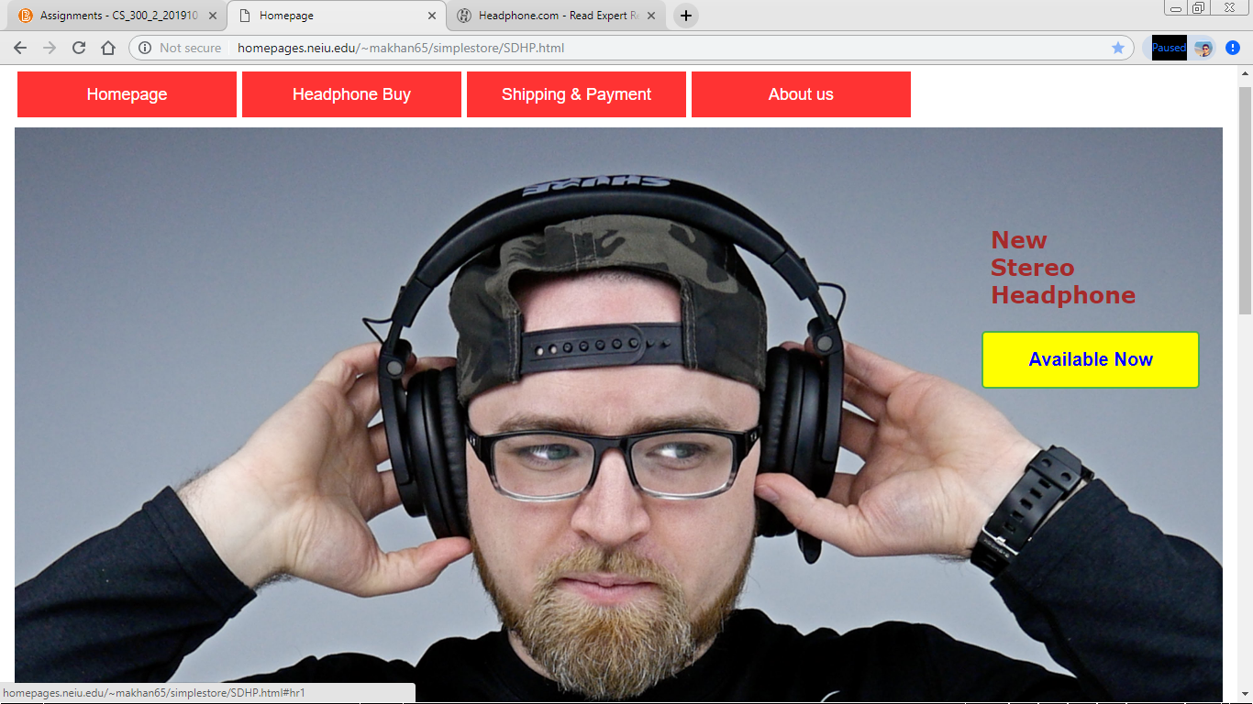

Template Sample



My Products

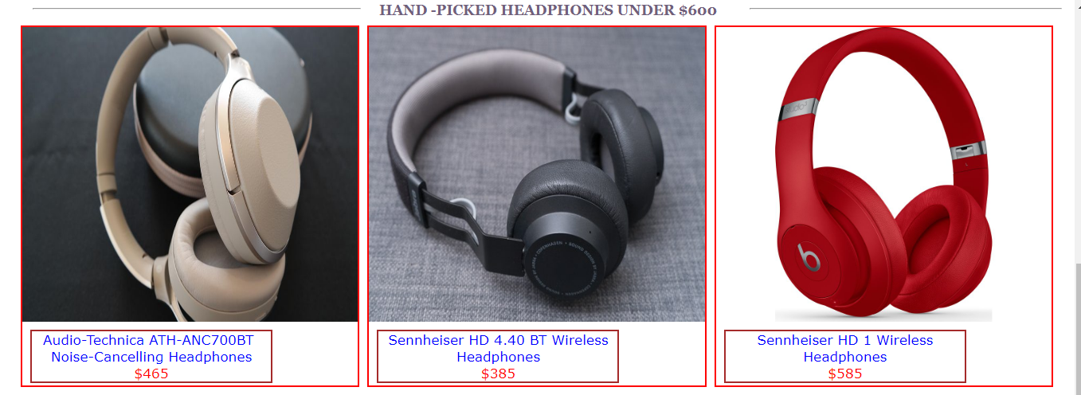



**Template products**

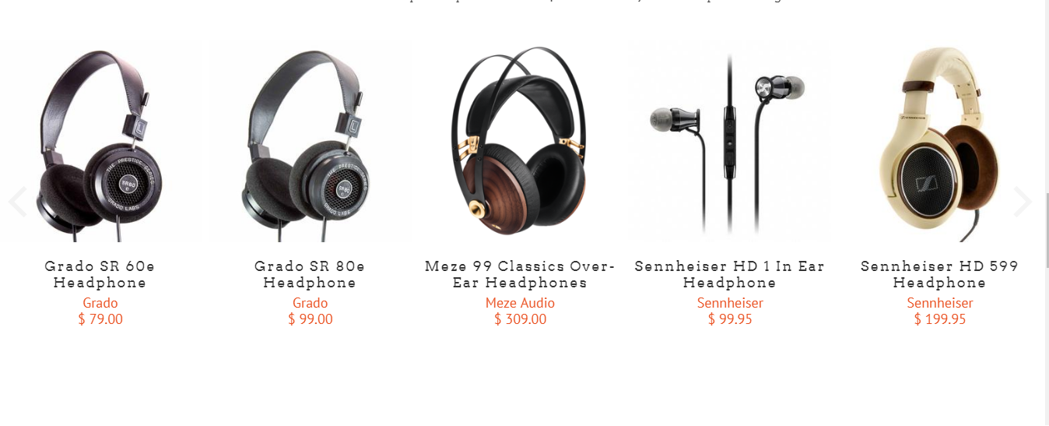

Once you click any of these products it will take you to the product Info page

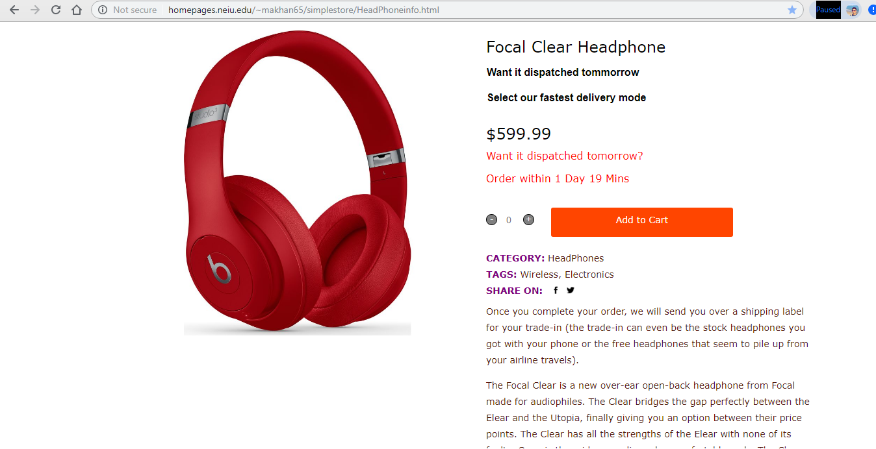

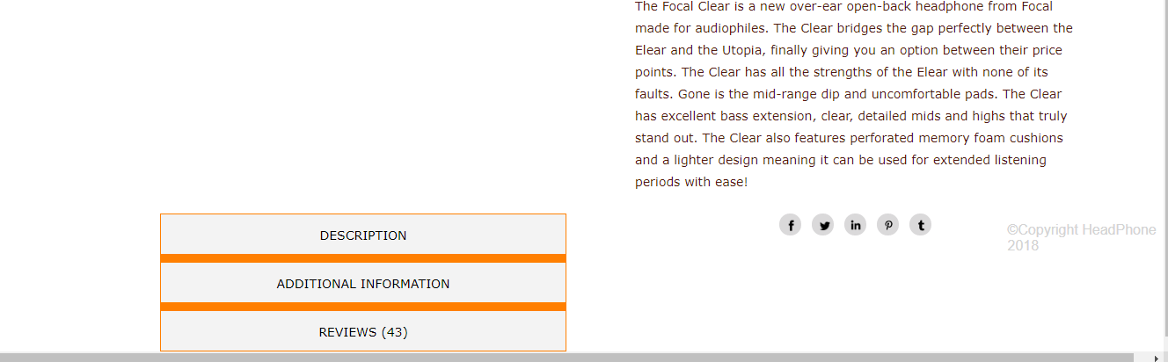

Template product Page

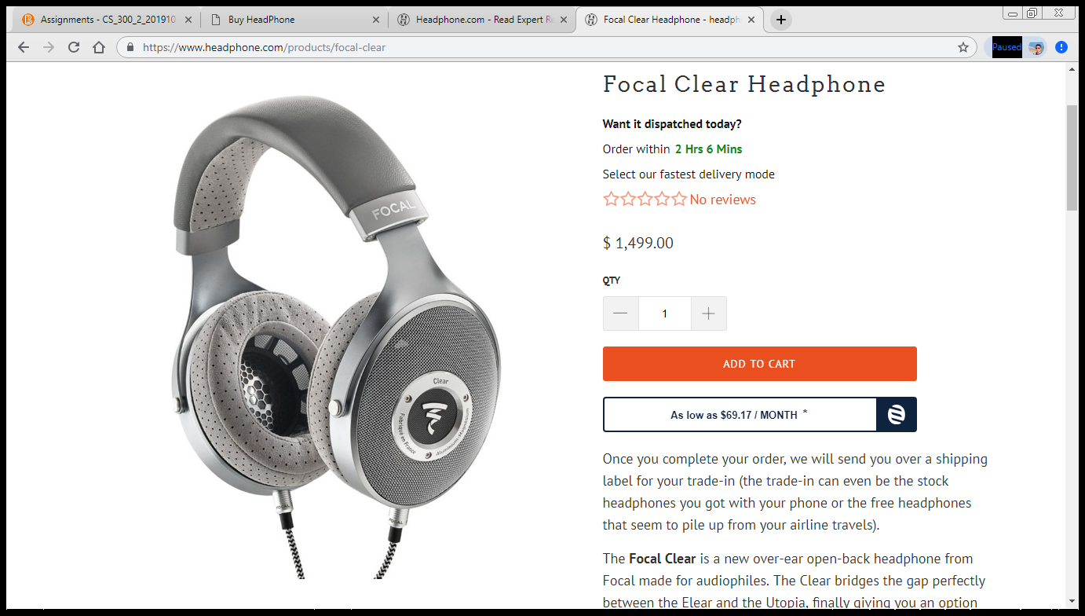

When you click on the Add to cart button on the page, it takes you to the cart



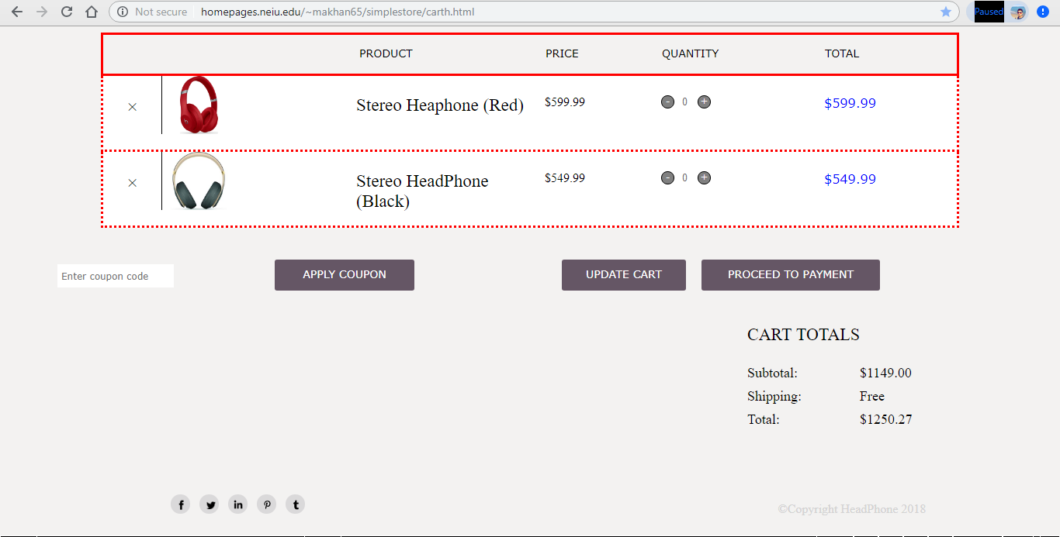

Once you click on proceed to payment button on the right side, it takes you to shipping and payment page.

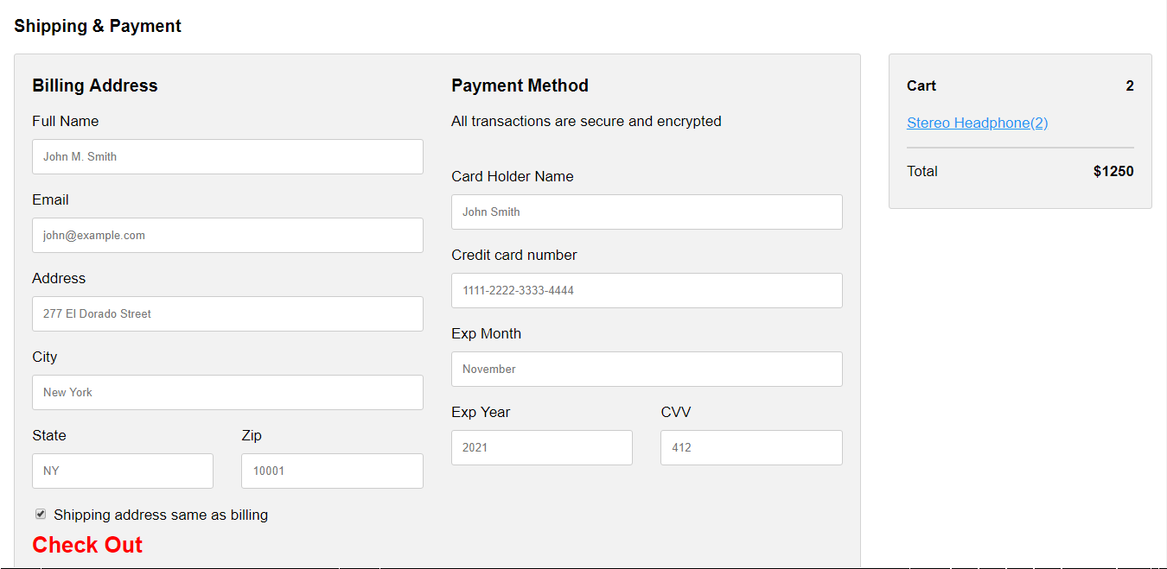

Once you click check out, you also get a pop up message confirming your purchase

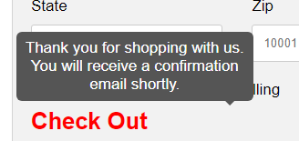

About US page

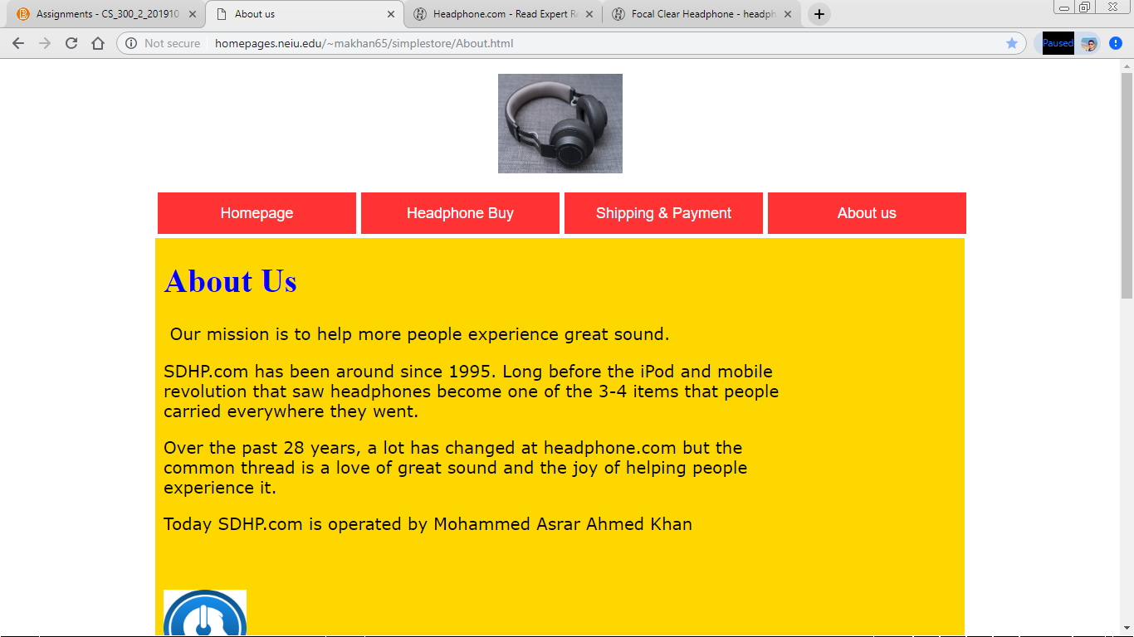

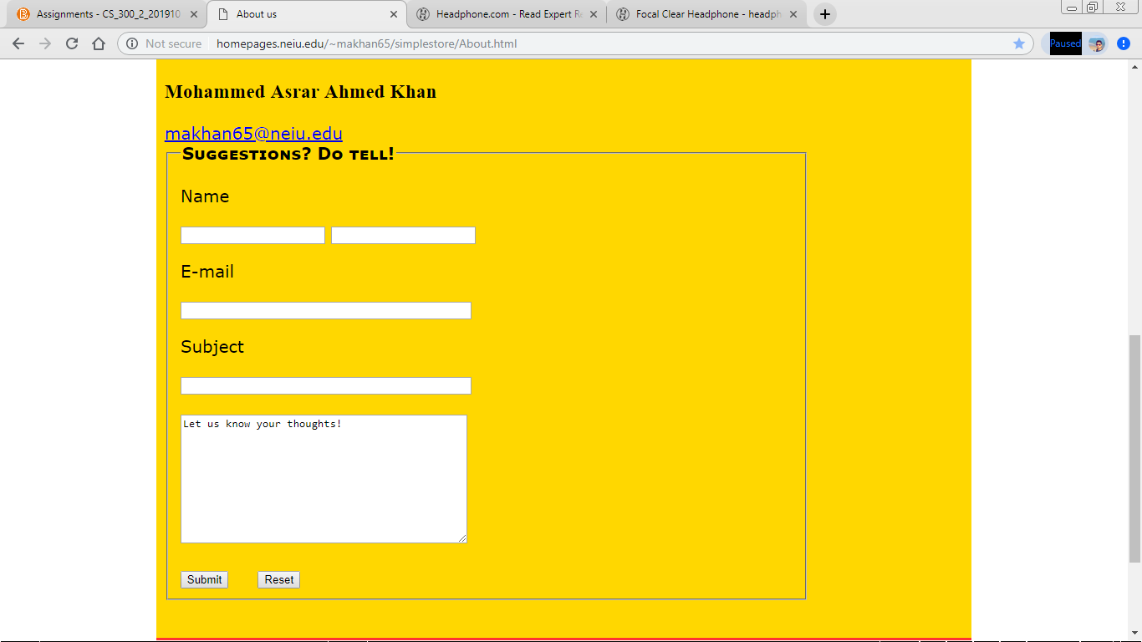



To access these five pages I also have a menu on the top of every page



Java Script

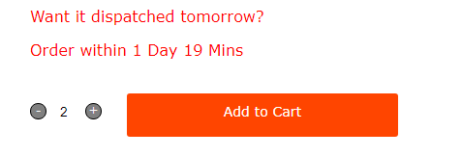

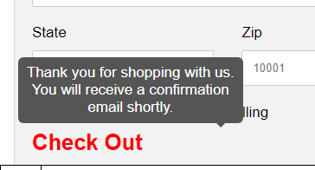

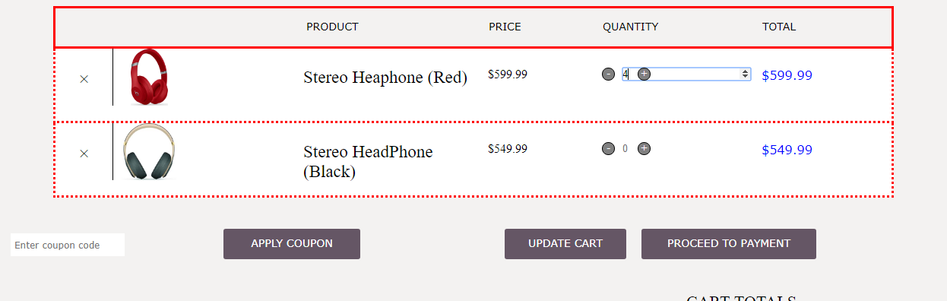



And Many more in the links……..